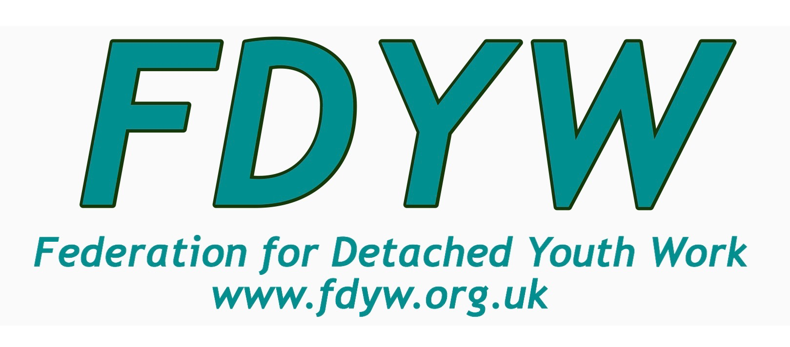
www.fdyw.org.uk
Managing Risk Assessment in detached Youth work

Risk Assessment in Detached Youth Work

The Federation for Detached Youth Work are responding to requests for information and support across the network in relation to a host of current topics and issues.

Risk Assessment has been a feature of the recent live webinar discussions, and the following guidance aims to support colleagues working through risk assessment with an enhancement relating to Covid-19.

Risk Assessment is an essential aspect of detached youth work which highlights the safety and wellbeing of young people, practitioners, and communities. Risk Assessment guidelines are required for your safety and are an organisational obligation. It is an active tool that supports the detached youth work team and can be used to inform change, develop innovation, and needs to be constantly updated. This is particularly important during the Covid-19 period.

The draft document below is an example only. It will require additional information specific to your project, location and context; together with managerial authorisation, to ensure safe and effective working practices.

HSE risk assessment templates are available via this link https://www.hse.gov.uk/risk/# in relation to policy adherence and active risk assessment. The development of risk assessment should have an agreed endorsement from the employer and management team and should be developed with the detached youth work team. Responsibility and accountability on managerial and practitioner levels are established through this process.

Practical Notes and Guidance with Reference to Covid-19:

To minimise risk of Young People contracting Covid-19 | To minimise risk of Youth Workers contracting Covid-19
Determine your intention whilst engaged in detached youth work. | Wash hand immediately before and after sessions.
Respond with consistent and responsive messaging regarding safe distancing and contact. | Use Personal Protective Equipment (PPE) and face mask/covering, gloves,
Be aware of the current regulations for Covid-19 and think of strategies to talk through with young people to limit risks. (A walk and talk strategy may be useful) | Carry anti-bacterial handwash,
Encourage safe distance contacts where feasible and promote safe hygiene messages. | Arrive and leave in separate vehicles and avoid public transport where possible.
Limit the types of activities that may require passing objects and provide information that can be given away. | Staff working at a safe practical distance from one another and young people. Attempt not to become a focal point for groups gathering.
Continue an open dialogue with young people regarding groups forming and the local by-laws and legislation as it develops. | Use wipes for phone if used to reduce transmission risk.
 | Immediately wash all clothes and ideally shower upon return home.

Risk assessment template

Company name: Detached Project Assessment carried out by: Me

Date of next review: July 1st 2020 Date assessment was carried out: June 1st 2020

What are the hazards? | Who might be harmed and how? | What are you already doing to control the risks? | What further action do you need to take to control the risks? | Who needs to carry out the action? | When is the action needed by? | Done
Hot weather | Workers and young people  Dehydration and sunstroke | Carrying sunscreen  Bottles of water | Advise to wear head gear  Move to shaded area  Activities short with more rests and water stops
Aggressive or Violent behaviour | Workers and young people  Physical or verbal attacks on individuals | Observing behaviour before entering area. Always have mobile phone and ID at hand  Make sure you and co-worker are always in sight of each other | Work in pairs  Management and Police know days and times detached team working  Conflict resolution skills if appropriate  Know your limitations  Walk away if you feel unsafe
Trips and slips | Youth workers  Pavements, rough ground, unstable area giving way etc | Assess area before entering, walking etc. Sturdy footwear | First Aid kit available and at least one first aid trained worker Don’t take risks Read and understand safety and policy procedures of your organisation
Covid Symptoms | All  Sneezing, coughing, touching | Wear mask when in enclosed space  Practice social distancing,  Wash hands at every opportunity and hand gel in pack to use regularly | Open conversation with young people about distance and washing hands  Take care not to touch people or surfaces  Cough or sneeze into mask or arm
Touching | Workers  Hand on arm or hug etc | Observe behaviour and actions Keep at a distance from young people  Read and understand safeguarding policy  All staff to have enhanced DBS | Make certain community recognise you and your work  Police knowledge of teams work  Be aware of others view of you  Staff to complete safeguarding training
Lack of light | Workers  Losing way, put in vulnerable position, Inciting fear in others | Always have a torch with you  Emergency call out available  Choose routes you know and are familiar with | Reconnaissance of new routes and new group hangouts  Assess areas new to you  Encourage groups to talk to you under streetlight if available
Crowding | All  Spreading virus to each other  Police could move them on and give asb. social distancing measures and rules on who you can meet | Role model  social distancing  Discussion about why it matters for their families/friends  Ideas for methods of talking and fun at a distance | Manager to have had discussion with Council, Police Community leaders etc  Police having knowledge and understanding of your work  Cards to give out explaining Covid info
Illegal actions | Young people | Observe before entering area, judge safety.  Community knowledge about work  ID and emergency call available | Know your work policies on substance use etc  Recognise that this is their space and walk away if you feel unsafe

More information on managing risk: www.hse.gov.uk/simple-health-safety/risk/

